**Que1. Write a update, delete trigger on clientmstr table. The System should keep track of the**

**records that ARE BEING updated or deleted. The old value of updated or deleted**

**records should be added in audit_trade table. (separate implementation using both row**

**and statement triggers)**

**Row level trigger:-**

create or replace trigger tt

after update or delete on client_18

for each row

declare

op varchar(10);

begin

if updating then

op:='update';

end if;

if deleting then

op:='delete';

end if;

insert into audit_18 values(:old.acc_no,op);

end;

/

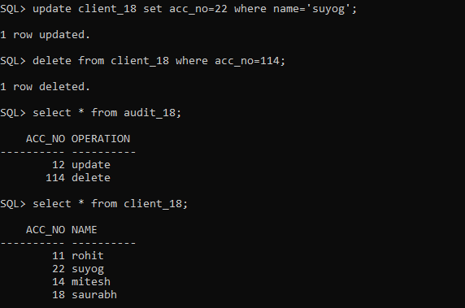

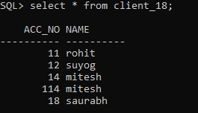

**Statement level trigger:-**

create or replace trigger tt

after update or delete on client_18

declare

op varchar(10);

begin

if updating then

op:='update';

end if;

if deleting then

op:='delete';

end if;

insert into audit_18 values('',op);

end;

/

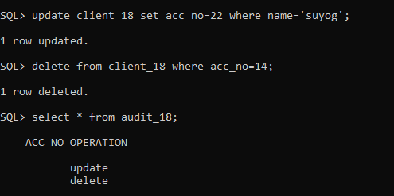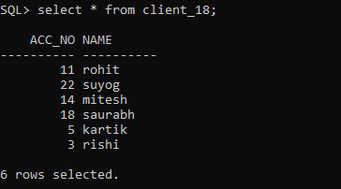

2. Write a before trigger for Insert, update event considering following requirement:

Emp(e_no, e_name, salary)

I) Trigger action should be initiated when salary is tried to be inserted is less than Rs.

50,000/-

II) Trigger action should be initiated when salary is tried to be updated for value less

than Rs. 50,000/-

Action should be rejection of update or Insert operation by displaying appropriate error

message. Also the new values expected to be inserted will be stored in new table

Tracking(e_no, salary).

**Trigger:-**

create or replace trigger before_t18 before insert or update on emp_18

for each row

DECLARE

op varchar(15);

BEGIN

if :new.salary<50000 then

insert into tracking_18 valueS(:new.e_no,:new.salary);

raise_application_error(-20003,'Salary should not be less than 50000');

else

dbms_output.put_line('Task Done');

end if;

if updating then

insert into tracking_18 values (:new.e_no,:new.salary);

end if;

END;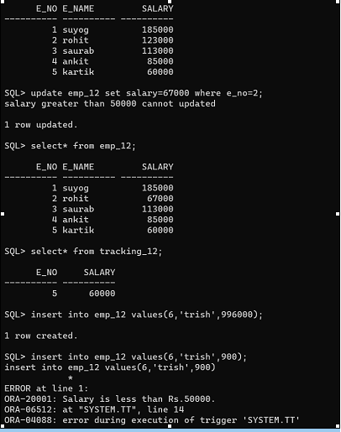

/

**QUE 3. Write a Database trigger for following requirements: Employee salary of last three month is stored in the emp_sal table. emp_sal(emp_no, sal1,sal2,sal3) before inserting salary into emp_sal table, if salary of employee in any of the last three month is greater than Rs. 50,000/- then entry of average salary along with emp_no needs to be inserted into new table emp_new(emp_no, avg_sal).**

**Trigger:-**

create or replace trigger t5

before insert on emp_sal18

for each row

declare

avg_salary number;

begin

avg_salary := (:new.sal1 + :new.sal2 + :new.sal3) / 3;

if :new.sal1 > 50000 or :new.sal2 > 50000 or :new.sal3 > 50000 then

insert into emp_new18 values(:new.e_no, avg_salary);

else

raise_application_error(-20001, 'Salaries do not exceed 50000');

end if;

end;

/

